**Babhta 1 Round 1**

1) Let the smallest of four consecutive whole numbers be .

Calculate, in terms of , the difference between the product of the two even numbers and the product of the two odd numbers.

2) Find the derivative of .

Answer in the form aSin(b*x*), where a and b N.

**Babhta 2 Round 2**

1) Find the equation of the circle which passes through the corners of the square with vertices (2, -1) , (5, 3) , (9, 0) and (6, -4). Answer in the form , where g, f and c  Z.

2) Dots are arranged in the following pattern:

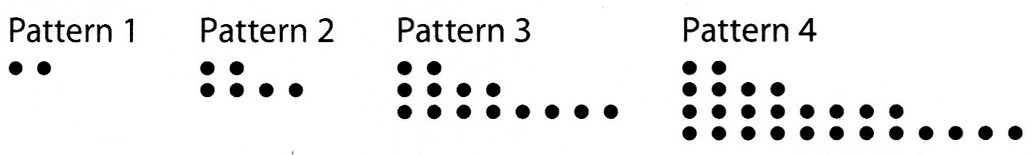

If this pattern continues how many dots will be in the 30th pattern?

**Babhta 3 Round 3**

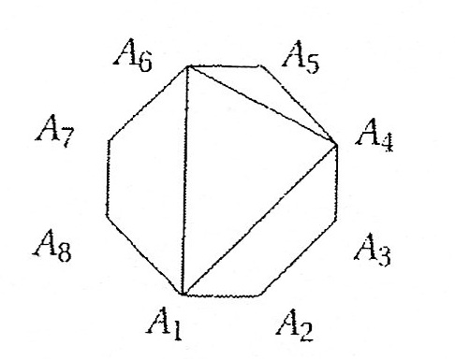

1) How many different triangles can you draw

as in the figure, if three vertices of the triangle

have to be among the points shown ?

2) A two-digit number, greater than 10, is written at random.

What is the probability that the sum of its digits is 5?

Answer in simplest form , where a and b 

**Babhta 4 Round 4**

1) ABCD is a rhombus in which the measure of the angle ABC is .

An equilateral triangle BCX is drawn on the side [BC], and a square DCYZ is drawn on the side [DC], both outside the rhombus.

Calculate the measure of the angle CXY.

Answer in degrees.

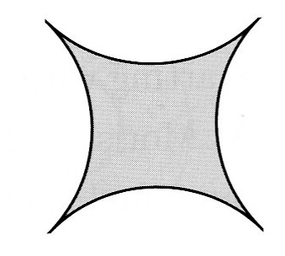 2) The figure shown is formed from four identical arcs, each a quarter of the circumference of a circle of radius 5 centimetres. What is the area of the figure in square centimetres?

Answer in the form a - b, where a and b 

**Babhta 5 Round 5**

1) Let  and  have opposite signs and satisfy the two equations

 and .

Find the numerical value of *xy*.

2) If (Sin(*x*)) = Sin(3*x*) calculate the numerical value of

(Cos())

**Babhta 6 Round 6**

1) The geometric mean of a set of n positive numbers is defined as the nth root of the product of those numbers. The geometric mean of a set of three numbers is 3 and the geometric mean of another set of three numbers is 12.

Calculate the numerical value of the geometric mean of the combined set of the six numbers.

2) A rhombus has half the area of a square with the same side length.

Calculate the ratio of the longer diagonal to the shorter diagonal of the rhombus.

Answer in the form , where 

**Babhta 7 Round 7**

1) Find the equation of the tangent to the curve  at the point where the curve crosses the

y-axis.

Answer in form a*x* +by + c =0 , where a , b and c 

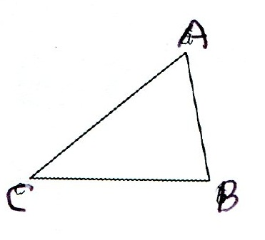

2) In the diagram |AC| = 2*x* , |BC| = 2*x* + 1 and |<ACB| = .

Given that the area of the triangle ABC is 18, calculate the value of *x*.

3) are positive integers and .

Find the numerical value of 

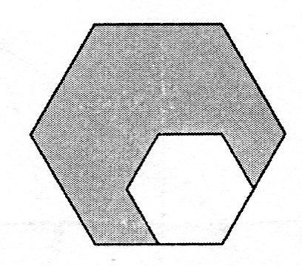4) The length of an edge of the large regular hexagon is twice the length of an edge of the small regular hexagon.

The small hexagon has an area of 4 .

Calculate the area of the large hexagon.

**Babhta 8 Round 8**

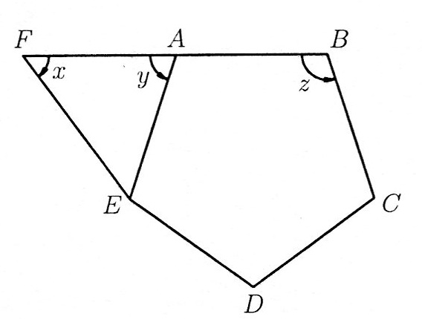

1) In the diagram ABCDE is a regular pentagon, and FAB is a straight line. .

Find the ratio of the angles  in simplest form : : , where 

2) The average of two positive numbers is 30% less than one of them and x% more than the second number.

Calculate the value of x.

3) In the figure below four different colours (red, yellow, blue and green) are available to colour the regions.

The only restrictions are that each region must be entirely one colour and no adjacent regions are allowed to have the same colour.

If at least three of the four colours are used how many different colouring schemes are possible?

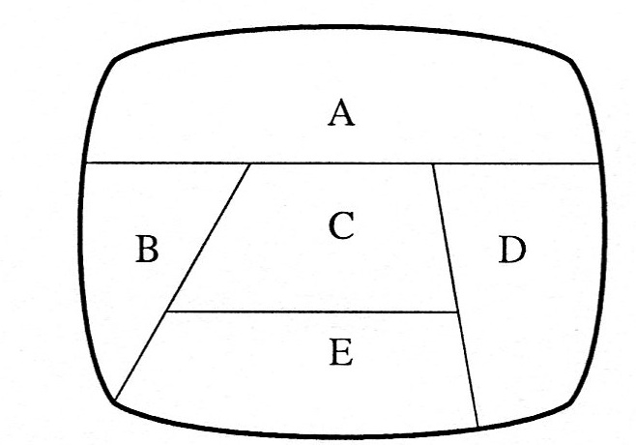

4) Pat purchases a car for €17 800 on January 1st. She makes a down payment of €1500 and then takes out a 5 year loan on the balance at an APR of 6%.

She agrees to repay the loan in equal monthly instalments beginning on the following February 1st and at the beginning of each subsequent month.

Calculate her monthly repayment to the nearest cent.